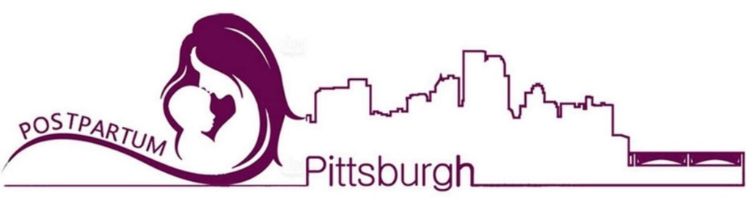

POSTPARTUM PITTSBURGH FALL EVENT
Continuing the Conversation: Resources to Support Equitable Perinatal Mental Health Care

October 19, 2023 3:30pm - 7:30pm
Wyndham Pittsburgh University Center · 100 Lytton Ave, Pittsburgh, PA 15213

Time | Content | Title | Presenter(s)
3:00–4:30 PM | Registration
3:30–3:45 PM | Welcome | Conference Introduction and Postpartum Pittsburgh Overview | Eydie Moses-Kolko, MD  Katherine Vital-Daley, MD
3:45–4:00 PM | Resources 1 | Hospital/Academic organizations providing perinatal mental health services | Women’s Behavioral Health (Allegheny Health Network)  UPMC Western Behavioral Health at Magee Womens Hospital, NEST  St Clair Health  Pregnancy Recovery Center – Magee Womens Hospital, UPMC Health Plan Maternity Program
4:10-4:25 PM | Resources 2 | Community-based organizations providing mental health services | Healthy Start Inc. Pittsburgh- Moving Beyond Depression  The Midwife Center  Women’s Center and Shelter of Greater Pittsburgh  Forward Wellness Counseling and Consulting
4:30-5:00 PM | Speaker 1 | Supporting intimate  partner violence survivors  in pediatric healthcare  settings | Maya Ragavan, MD, MPH, MS
5:00–5:30 PM | Speaker 2 | Provider strategies to maintain personal wellness and prevent burnout | Khavah Murray, LCSW, CCTP, CGS
5:30–5:45 PM | Q&A | Facilitator: Montia Brock, LPC, NCC, IMH-E, CLC, CD(DONA) | Maya Ragavan, MD, MPH, MS and  Khavah Murray, LCSW, CCTP, CGS
5:45 PM | Dinner Buffet is open
6:30-6:45 PM | Resources 3 | Emotional wellness supports & basic needs in community | Pittsburgh Bereavement Doulas  Nurture PA  Hello Neighbor  Women Against Abusive relationships  WIC - Allegheny County Health Department  Beverly’s Birthdays
6:45-7:00 PM | Resources 4 | Child and Family Centers | Jeremiah's Place  Alliance for Infants and Toddlers  Early Head Start Allegheny Intermediate Unit
7:00-7:30 PM | Closing comments & Adjournment Katherine Vital-Daley, MD

